**CS 628 Full-Stack Development II**

**HOS05A: Views –Home Page with locations_list.pug**

July 19, 2020

12/29/2020 Updated by Min

School of Technology & Computing (STC)

City University of Seattle (CityU)

**Before You Start**

* The directory path shown in screenshots may be different from yours.
* Some steps are not explained in the tutorial**.** If you are not sure what to do:
  1. Consult the resources listed below.
  2. If you cannot solve the problem after a few tries, ask a TA for help.

**Resources**

* Holmes, S. & Harber, C. (2019). [Getting MEAN with Mongo, Express, Angular, and Node, Second Edition](https://login.proxy.cityu.edu/sso/skillport?context=148121). Manning Publications. (ISBN 9781617294754)
  + 4.3.3 Building a Template
* Pug, <https://pugjs.org/api/getting-started.html>

**Course Concepts**

* Understand the template engine in Express - Pug
* Understand a front-end layout framework
* Apply the locations_list.pug to the homepage of an Express web application.

**Activities**

* Preparing for a MEAN project environment
* **Defining a Layout for the Homepage**
* **Setting up the View and the Controller for the Homepage**
* **Coding the Template for the Homepage: Page Layout**
* **Coding the Template for the Homepage: Locations List**
* Source Code Management and Deployment

**Preparing for a MEAN project environment**

1. Copy the “module04b” directory to the “module05a” one.
2. Open the “module05a” folder in the VSCode.  
   Close the “Welcome” window.  
   Open the terminal (Ctrl+`).
3. Test whether the application works correctly.  
   >>>npm start  
     
   <http://localhost:3000>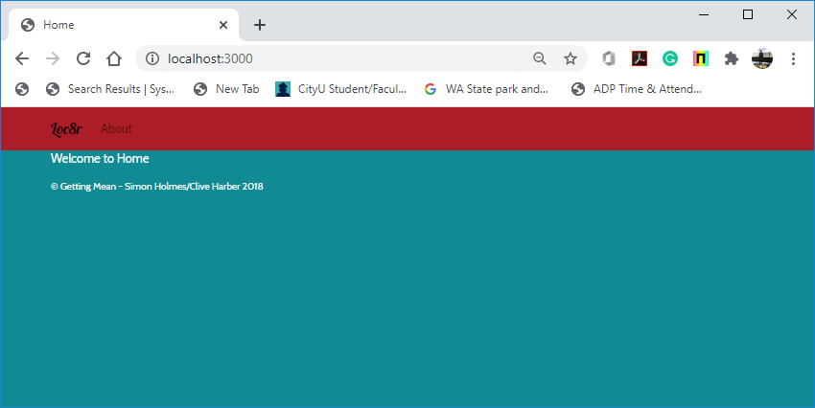

##### **Defining a Layout for the Homepage**

1. Understand the desktop and mobile layout sketches for the homepage.

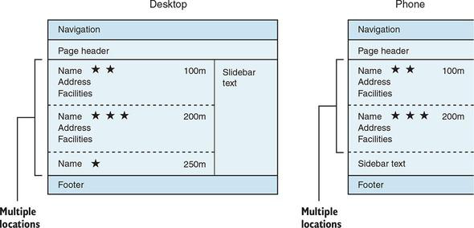

**Setting up the View and the Controller for the Homepage**

1. Create a new view file “locations-list.pug” under the “app_server/views” directory by copying the “index.pug” view file.

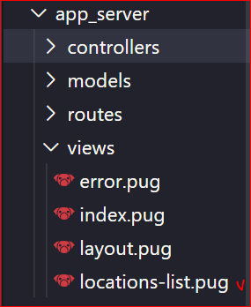

1. Tell the controller for the homepage that you want to use this new view “locations-list.pug.”
   1. The controller for the homepage is in the “locations.js” file in “app_server/controllers.”
   2. Update this “locations.js” file to change the view called by the “homelist” controller, as shown in the following code snippet:

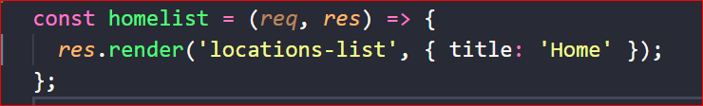

**Coding the Template for the Homepage: Page Layout**

1. You focus on the three main areas - the page header, the main area for the list, and the sidebar to consider.   
   Update the “locations-list.pug”HTML view template with the given Pug code.

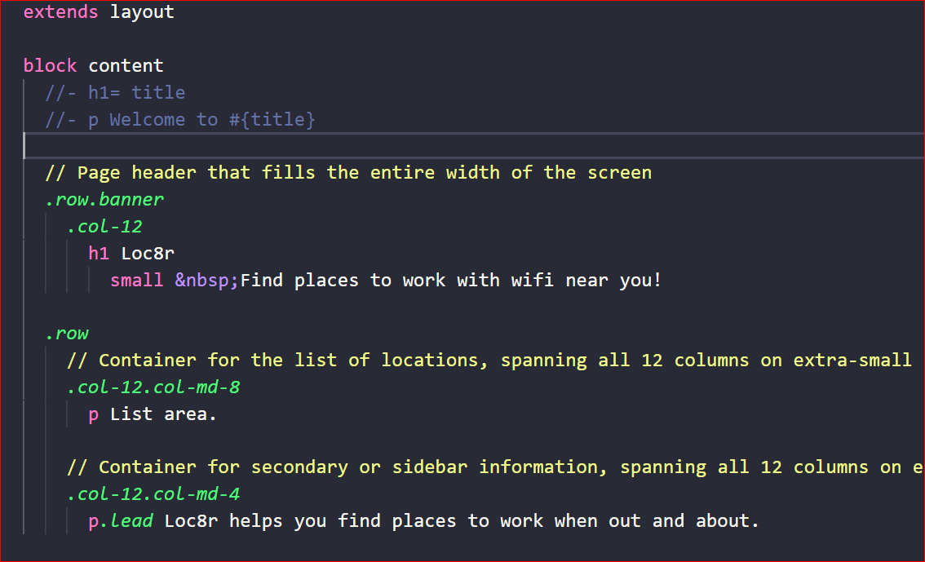

1. Run the application for testing.   
   >>>npm start

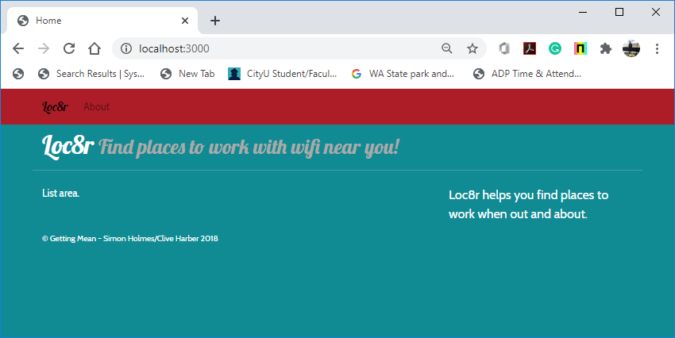

**Note:** Because you are creating a clickable prototype, all the data will be hardcoded into the template for now. (Later, the data side will be moved to the controllers.)

**Coding the Template for the Homepage: Locations List**

Now that the containers for the homepage are defined, build the view for the main area.

1. Create a new Bootstrap card and card block to wrap the content.   
   Show the name of the listing and a link to the location.  
   Test the template by clicking the card block.

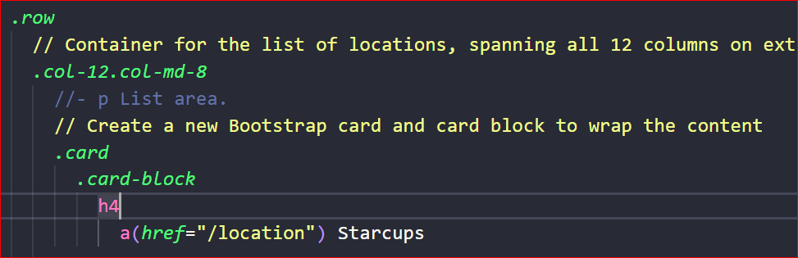

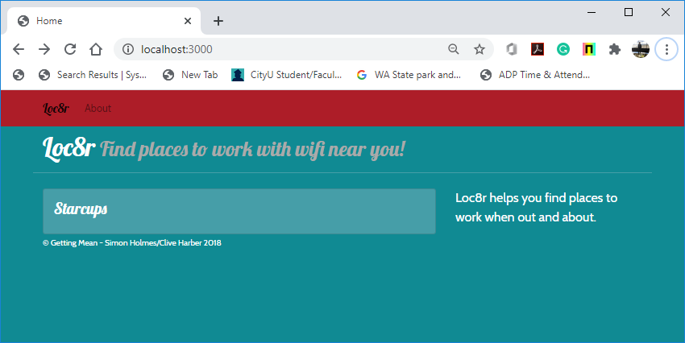

1. Use Font Awesome icons to output a star rating.

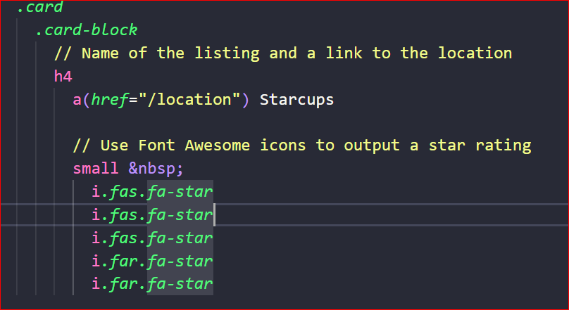

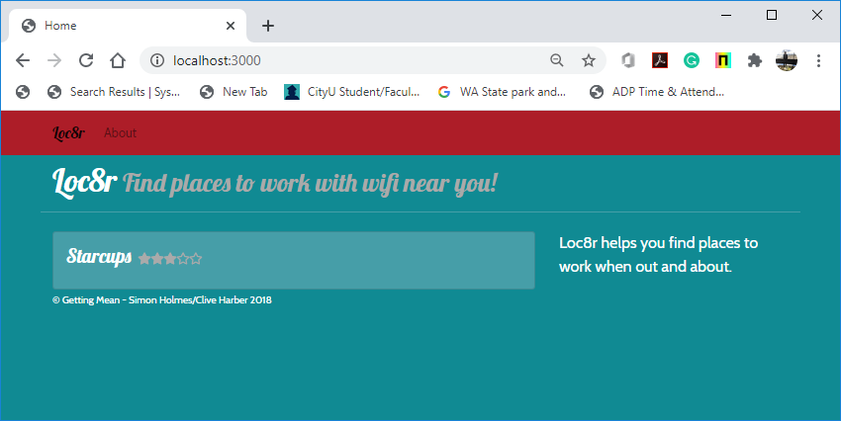

1. Use Bootstrap’s badge helper class to display the distance away.

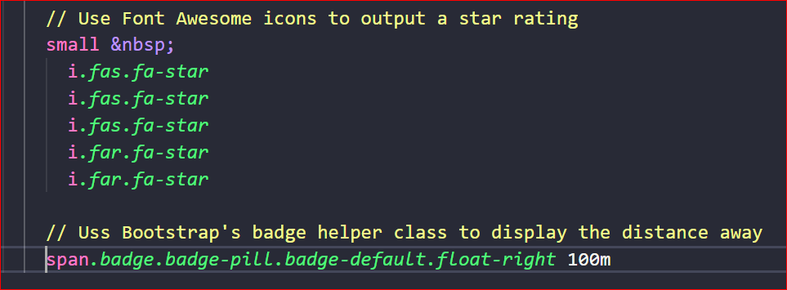

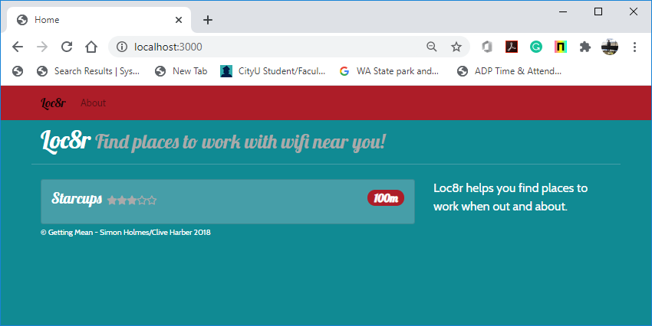

1. Show the address of the location.

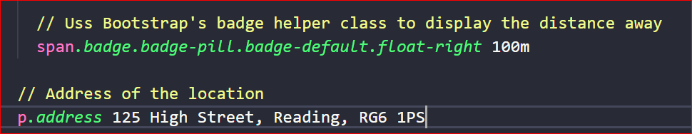

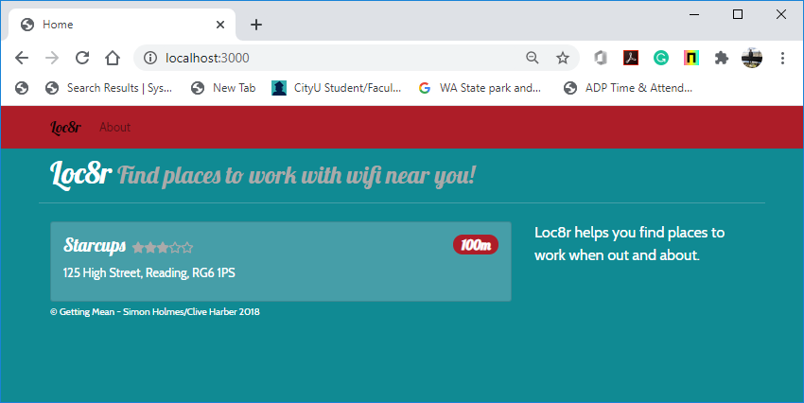

1. Facilities of the location, output using Bootstrap’s badge classes.

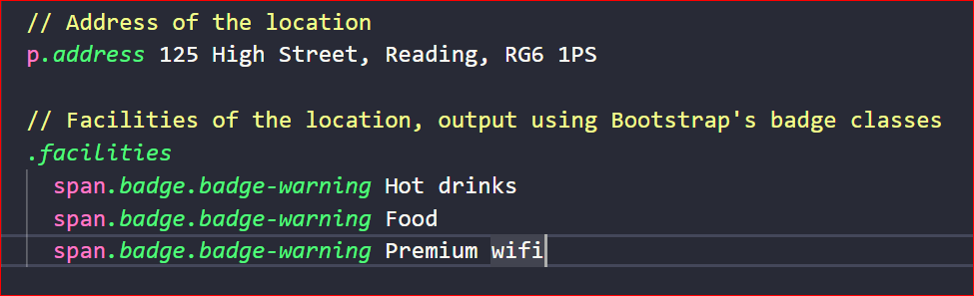

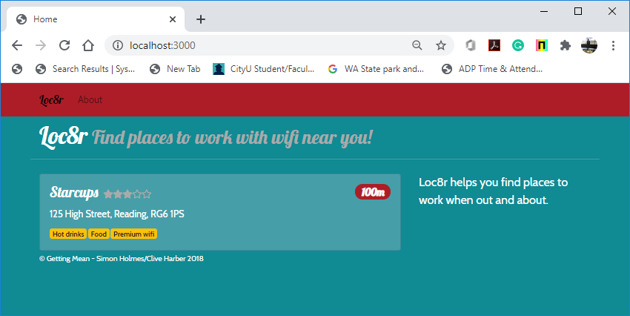

**Source Code Management and Deployment**

**Push your work to GitHub**

Run the following commands to push your work to the GitHub repository:

Open the terminal from the VSCode by hitting the control + ~ key and type the following command:

>>> git add .

>>> git commit -m “Submission for Module 5A --yourname”

>>> git push origin master

**Push your work to Heroku**

>>> git push heroku master

If you cannot remember your branch name, run the command “git status” to check.